**Homework 2**

1. Refer to the CATS1 dataset. Write a SAS program to read the data file from your USB with an INFILE statement and print the dataset. There should be eight observations and two variables.

Code:

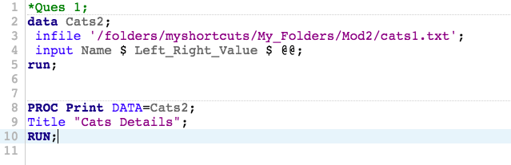

Log:

|  |
| --- |
| 1 OPTIONS NONOTES NOSTIMER NOSOURCE NOSYNTAXCHECK;  72  73 *Ques 1;  74 data Cats2;  75 infile '/folders/myshortcuts/My_Folders/Mod2/cats1.txt';  76 input Name $ Left_Right_Value $ @@;  77 run;    NOTE: The infile '/folders/myshortcuts/My_Folders/Mod2/cats1.txt' is:  Filename=/folders/myshortcuts/My_Folders/Mod2/cats1.txt,  Owner Name=root,Group Name=vboxsf,  Access Permission=-rwxrwx---,  Last Modified=13Feb2018:11:55:33,  File Size (bytes)=132    NOTE: 2 records were read from the infile '/folders/myshortcuts/My_Folders/Mod2/cats1.txt'.  The minimum record length was 64.  The maximum record length was 64.  NOTE: SAS went to a new line when INPUT statement reached past the end of a line.  NOTE: The data set WORK.CATS2 has 8 observations and 2 variables.  NOTE: DATA statement used (Total process time):  real time 0.00 seconds  cpu time 0.00 seconds      78  79  80 PROC Print DATA=Cats2;  81 Title "Cats Details";  82 RUN;    NOTE: There were 8 observations read from the data set WORK.CATS2.  NOTE: PROCEDURE PRINT used (Total process time):  real time 0.05 seconds  cpu time 0.06 seconds      83  84  85 OPTIONS NONOTES NOSTIMER NOSOURCE NOSYNTAXCHECK;  98 |

Results:

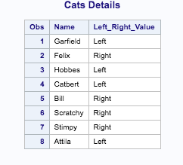

1. Refer to the DOGS1 dataset. Write a SAS program to read the data file from your USB with an INFILE statement and print the dataset. There should be 25 observations and six variables.

Code:

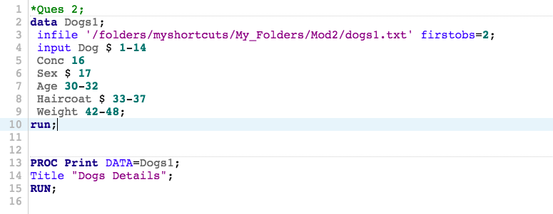

Log:

|  |
| --- |
| 1 OPTIONS NONOTES NOSTIMER NOSOURCE NOSYNTAXCHECK;  72  73 *Ques 2;  74 data Dogs1;  75 infile '/folders/myshortcuts/My_Folders/Mod2/dogs1.txt' firstobs=2;  76 input Dog $ 1-14  77 Conc 16  78 Sex $ 17  79 Age 30-32  80 Haircoat $ 33-37  81 Weight 42-48;  82 run;    NOTE: The infile '/folders/myshortcuts/My_Folders/Mod2/dogs1.txt' is:  Filename=/folders/myshortcuts/My_Folders/Mod2/dogs1.txt,  Owner Name=root,Group Name=vboxsf,  Access Permission=-rwxrwx---,  Last Modified=13Feb2018:11:55:41,  File Size (bytes)=1274    NOTE: 25 records were read from the infile '/folders/myshortcuts/My_Folders/Mod2/dogs1.txt'.  The minimum record length was 48.  The maximum record length was 48.  NOTE: The data set WORK.DOGS1 has 25 observations and 6 variables.  NOTE: DATA statement used (Total process time):  real time 0.01 seconds  cpu time 0.01 seconds      83  84  85 PROC Print DATA=Dogs1;  86 Title "Dogs Details";  87 RUN;    NOTE: There were 25 observations read from the data set WORK.DOGS1.  NOTE: PROCEDURE PRINT used (Total process time):  real time 0.10 seconds  cpu time 0.10 seconds      88  89  90 OPTIONS NONOTES NOSTIMER NOSOURCE NOSYNTAXCHECK;  103 |

Results:

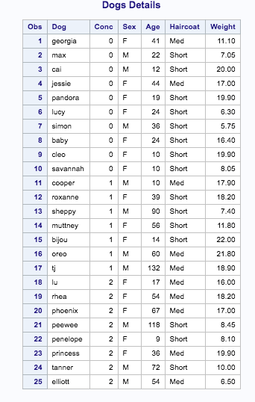

1. Refer to the BREAD dataset. Write a SAS program to read the data using DATALINES. There should be 11 observations and 11 variables.

Code:

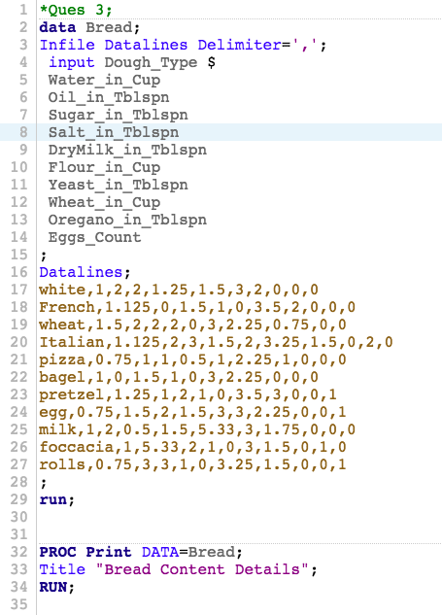

Log:

|  |
| --- |
| 1 OPTIONS NONOTES NOSTIMER NOSOURCE NOSYNTAXCHECK;  72  73 *Ques 3;  74 data Bread;  75 Infile Datalines Delimiter=',';  76 input Dough_Type $  77 Water_in_Cup  78 Oil_in_Tblspn  79 Sugar_in_Tblspn  80 Salt_in_Tblspn  81 DryMilk_in_Tblspn  82 Flour_in_Cup  83 Yeast_in_Tblspn  84 Wheat_in_Cup  85 Oregano_in_Tblspn  86 Eggs_Count  87 ;  88 Datalines;    NOTE: The data set WORK.BREAD has 11 observations and 11 variables.  NOTE: DATA statement used (Total process time):  real time 0.00 seconds  cpu time 0.01 seconds    100 ;    101 run;  102  103  104 PROC Print DATA=Bread;  105 Title "Bread Content Details";  106 RUN;    NOTE: There were 11 observations read from the data set WORK.BREAD.  NOTE: PROCEDURE PRINT used (Total process time):  real time 0.09 seconds  cpu time 0.08 seconds      107  108  109  110 OPTIONS NONOTES NOSTIMER NOSOURCE NOSYNTAXCHECK;  123 |

Results:

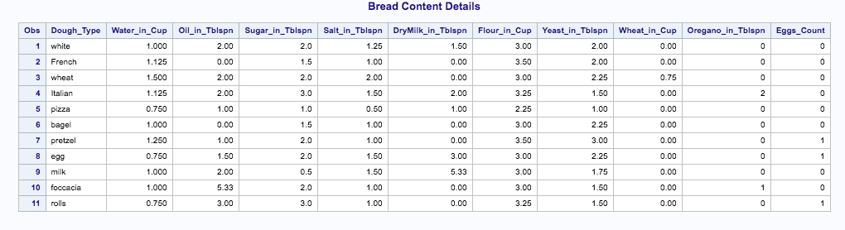

1. Refer to the grades below. Write a SAS program which uses a DATALINES command, not an INFILE statement and print the dataset. Copy and paste the numbers from the text file into your SAS program.

Ann/84/90/A-/0

Bill/78/84/B/0

Cathy/95/89/A/1

David/84/88/B+/1

Code:

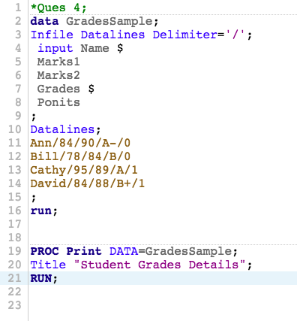

Log:

|  |
| --- |
| 1 OPTIONS NONOTES NOSTIMER NOSOURCE NOSYNTAXCHECK;  72  73 *Ques 4;  74 data GradesSample;  75 Infile Datalines Delimiter='/';  76 input Name $  77 Marks1  78 Marks2  79 Grades $  80 Ponits  81 ;  82 Datalines;    NOTE: The data set WORK.GRADESSAMPLE has 4 observations and 5 variables.  NOTE: DATA statement used (Total process time):  real time 0.00 seconds  cpu time 0.00 seconds    87 ;    88 run;  89  90  91 PROC Print DATA=GradesSample;  92 Title "Student Grades Details";  93 RUN;    NOTE: There were 4 observations read from the data set WORK.GRADESSAMPLE.  NOTE: PROCEDURE PRINT used (Total process time):  real time 0.05 seconds  cpu time 0.04 seconds      94  95  96  97 OPTIONS NONOTES NOSTIMER NOSOURCE NOSYNTAXCHECK;  110 |

Results:

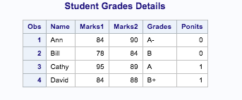

1. Refer to the SOCCER dataset. Write a SAS program to read the data file from your USB with an INFILE statement and print the dataset. Read the feet and inches in the heights of the players as two separate variables. There should be 32 observations and 8 variables. Make sure that your program correctly interprets Lynn Pattishall’s jersey number as 00. The variables are: number firstname lastname code feet inches level jersey

Code:

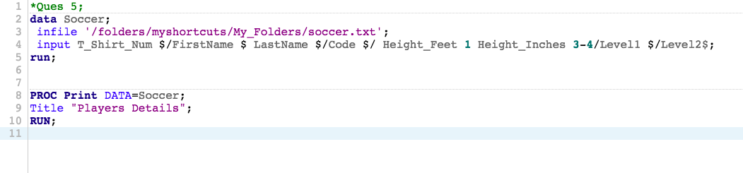

Log:

|  |
| --- |
| 1 OPTIONS NONOTES NOSTIMER NOSOURCE NOSYNTAXCHECK;  72  73 *Ques 5;  74 data Soccer;  75 infile '/folders/myshortcuts/My_Folders/soccer.txt';  76 input T_Shirt_Num $/FirstName $ LastName $/Code $/ Height_Feet 1 Height_Inches 3-4/Level1 $/Level2$;  77 run;    NOTE: The infile '/folders/myshortcuts/My_Folders/soccer.txt' is:  Filename=/folders/myshortcuts/My_Folders/soccer.txt,  Owner Name=root,Group Name=vboxsf,  Access Permission=-rwxrwx---,  Last Modified=13Feb2018:09:50:48,  File Size (bytes)=4608    NOTE: 192 records were read from the infile '/folders/myshortcuts/My_Folders/soccer.txt'.  The minimum record length was 22.  The maximum record length was 22.  NOTE: The data set WORK.SOCCER has 32 observations and 8 variables.  NOTE: DATA statement used (Total process time):  real time 0.01 seconds  cpu time 0.00 seconds      78  79  80 PROC Print DATA=Soccer;  81 Title "Players Details";  82 RUN;    NOTE: There were 32 observations read from the data set WORK.SOCCER.  NOTE: PROCEDURE PRINT used (Total process time):  real time 0.13 seconds  cpu time 0.14 seconds      83  84  85 OPTIONS NONOTES NOSTIMER NOSOURCE NOSYNTAXCHECK;  98 |

Results:

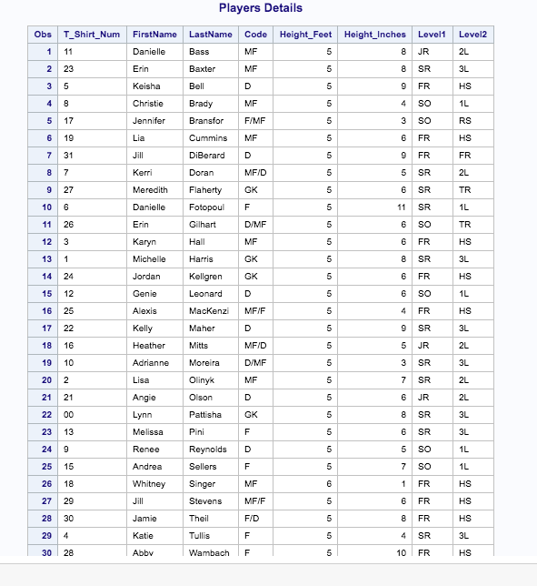

1. Refer to the CATS3 dataset. Write a SAS program to read the data file from your USB with an INFILE statement, write a permanent SAS dataset onto your USB, and print the dataset. There should be 8 observations and five variables.

Code:

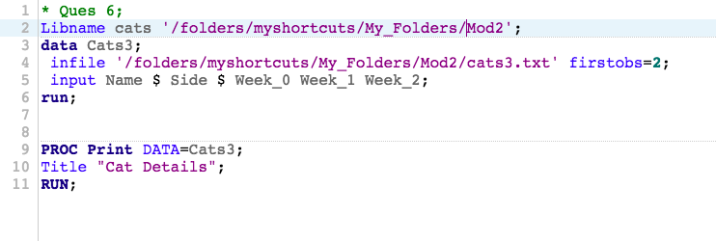

Log:

|  |
| --- |
| 1 OPTIONS NONOTES NOSTIMER NOSOURCE NOSYNTAXCHECK;  72  73 * Ques 6;  74 Libname cats '/folders/myshortcuts/My_Folders/Mod2';  NOTE: Libref CATS was successfully assigned as follows:  Engine: V9  Physical Name: /folders/myshortcuts/My_Folders/Mod2  75 data Cats3;  76 infile '/folders/myshortcuts/My_Folders/Mod2/cats3.txt' firstobs=2;  77 input Name $ Side $ Week_0 Week_1 Week_2;  78 run;    NOTE: The infile '/folders/myshortcuts/My_Folders/Mod2/cats3.txt' is:  Filename=/folders/myshortcuts/My_Folders/Mod2/cats3.txt,  Owner Name=root,Group Name=vboxsf,  Access Permission=-rwxrwx---,  Last Modified=13Feb2018:11:55:37,  File Size (bytes)=394    NOTE: 8 records were read from the infile '/folders/myshortcuts/My_Folders/Mod2/cats3.txt'.  The minimum record length was 41.  The maximum record length was 43.  NOTE: The data set WORK.CATS3 has 8 observations and 5 variables.  NOTE: DATA statement used (Total process time):  real time 0.01 seconds  cpu time 0.02 seconds      79  80  81 PROC Print DATA=Cats3;  82 Title "Cat Details";  83 RUN;    NOTE: There were 8 observations read from the data set WORK.CATS3.  NOTE: PROCEDURE PRINT used (Total process time):  real time 0.06 seconds  cpu time 0.06 seconds      84  85 OPTIONS NONOTES NOSTIMER NOSOURCE NOSYNTAXCHECK;  98 |

Results:

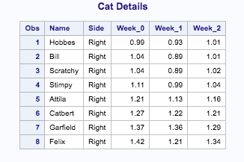

1. Refer to the MANATEES dataset. Write a SAS program to read the data file from your USB with an INFILE statement and print the dataset. There should be 23 observations and seven variables.

Code:

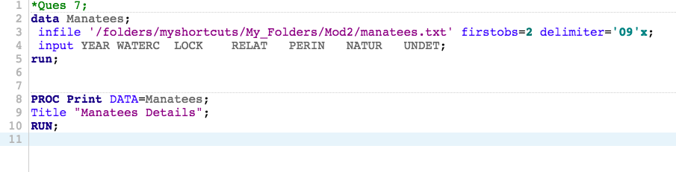

Log:

|  |
| --- |
| 1 OPTIONS NONOTES NOSTIMER NOSOURCE NOSYNTAXCHECK;  72  73 *Ques 7;  74 data Manatees;  75 infile '/folders/myshortcuts/My_Folders/Mod2/manatees.txt' firstobs=2 delimiter='09'x;  76 input YEARWATERCLOCKRELATPERINNATURUNDET;  77 run;    NOTE: The infile '/folders/myshortcuts/My_Folders/Mod2/manatees.txt' is:  Filename=/folders/myshortcuts/My_Folders/Mod2/manatees.txt,  Owner Name=root,Group Name=vboxsf,  Access Permission=-rwxrwx---,  Last Modified=13Feb2018:11:55:58,  File Size (bytes)=540    NOTE: 23 records were read from the infile '/folders/myshortcuts/My_Folders/Mod2/manatees.txt'.  The minimum record length was 17.  The maximum record length was 23.  NOTE: The data set WORK.MANATEES has 23 observations and 7 variables.  NOTE: DATA statement used (Total process time):  real time 0.01 seconds  cpu time 0.00 seconds      78  79  80 PROC Print DATA=Manatees;  81 Title "Manatees Details";  82 RUN;    NOTE: There were 23 observations read from the data set WORK.MANATEES.  NOTE: PROCEDURE PRINT used (Total process time):  real time 0.10 seconds  cpu time 0.11 seconds      83  84  85 OPTIONS NONOTES NOSTIMER NOSOURCE NOSYNTAXCHECK;  98 |

Results:

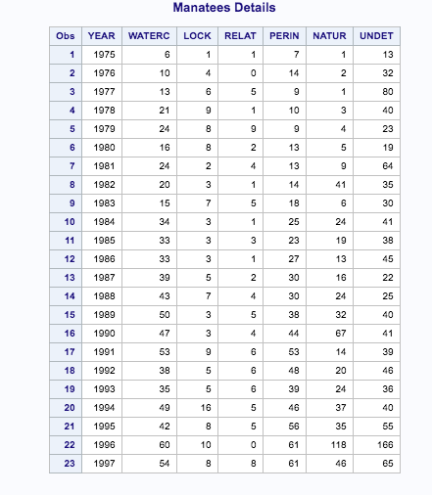

1. Refer to the DOGS2 dataset. Write a SAS program to read the data file from your USB with an INFILE statement, write a permanent SAS dataset onto your USB, and print the dataset. There should be 25 observations and four variables.

Code:

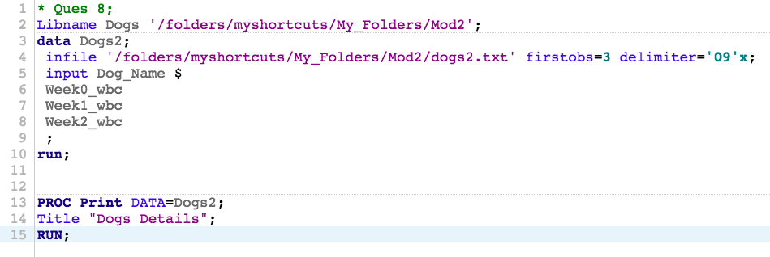

Log:

|  |
| --- |
| 1 OPTIONS NONOTES NOSTIMER NOSOURCE NOSYNTAXCHECK;  72  73 * Ques 8;  74 Libname Dogs '/folders/myshortcuts/My_Folders/Mod2';  NOTE: Libref DOGS refers to the same physical library as CATS.  NOTE: Libref DOGS was successfully assigned as follows:  Engine: V9  Physical Name: /folders/myshortcuts/My_Folders/Mod2  75 data Dogs2;  76 infile '/folders/myshortcuts/My_Folders/Mod2/dogs2.txt' firstobs=3 delimiter='09'x;  77 input Dog_Name $  78 Week0_wbc  79 Week1_wbc  80 Week2_wbc  81 ;  82 run;    NOTE: The infile '/folders/myshortcuts/My_Folders/Mod2/dogs2.txt' is:  Filename=/folders/myshortcuts/My_Folders/Mod2/dogs2.txt,  Owner Name=root,Group Name=vboxsf,  Access Permission=-rwxrwx---,  Last Modified=13Feb2018:11:55:44,  File Size (bytes)=688    NOTE: 25 records were read from the infile '/folders/myshortcuts/My_Folders/Mod2/dogs2.txt'.  The minimum record length was 23.  The maximum record length was 26.  NOTE: The data set WORK.DOGS2 has 25 observations and 4 variables.  NOTE: DATA statement used (Total process time):  real time 0.01 seconds  cpu time 0.01 seconds      83  84  85 PROC Print DATA=Dogs2;  86 Title "Dogs Details";  87 RUN;    NOTE: There were 25 observations read from the data set WORK.DOGS2.  NOTE: PROCEDURE PRINT used (Total process time):  real time 0.08 seconds  cpu time 0.06 seconds      88  89 OPTIONS NONOTES NOSTIMER NOSOURCE NOSYNTAXCHECK;  102 |

Results:

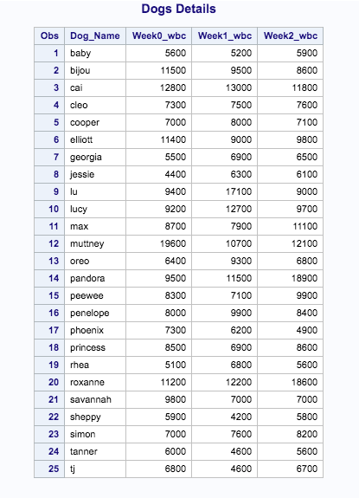

1. Use stocks.txt which contains a stock symbol, a price, and the number of shares.
2. Using this raw data file, create a temporary SAS data set (Portfolio). Choose your own variable names for the stock symbol, price, and number of shares. In addition create a new variable (call it Value) equal to the stock price times the number of shares. Include a comment in your program, your name, and the date the program was written.
3. Write the appropriate statements to compute the average price and the average number of shares of your stocks.

Code:

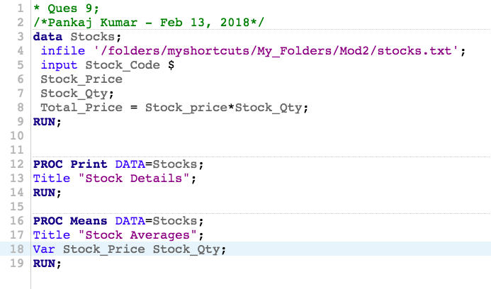

Log:

|  |
| --- |
| 1 OPTIONS NONOTES NOSTIMER NOSOURCE NOSYNTAXCHECK;  72  73 * Ques 9;  74 /*Pankaj Kumar - Feb 13, 2018*/  75 data Stocks;  76 infile '/folders/myshortcuts/My_Folders/Mod2/stocks.txt';  77 input Stock_Code $  78 Stock_Price  79 Stock_Qty;  80 Total_Price = Stock_price*Stock_Qty;  81 RUN;    NOTE: The infile '/folders/myshortcuts/My_Folders/Mod2/stocks.txt' is:  Filename=/folders/myshortcuts/My_Folders/Mod2/stocks.txt,  Owner Name=root,Group Name=vboxsf,  Access Permission=-rwxrwx---,  Last Modified=13Feb2018:11:56:06,  File Size (bytes)=88    NOTE: 6 records were read from the infile '/folders/myshortcuts/My_Folders/Mod2/stocks.txt'.  The minimum record length was 12.  The maximum record length was 14.  NOTE: The data set WORK.STOCKS has 6 observations and 4 variables.  NOTE: DATA statement used (Total process time):  real time 0.00 seconds  cpu time 0.01 seconds      82  83  84 PROC Print DATA=Stocks;  85 Title "Stock Details";  86 RUN;    NOTE: There were 6 observations read from the data set WORK.STOCKS.  NOTE: PROCEDURE PRINT used (Total process time):  real time 0.05 seconds  cpu time 0.06 seconds      87  88 PROC Means DATA=Stocks;  89 Title "Stock Averages";  90 Var Stock_Price Stock_Qty;  91 RUN;    NOTE: There were 6 observations read from the data set WORK.STOCKS.  NOTE: PROCEDURE MEANS used (Total process time):  real time 0.05 seconds  cpu time 0.05 seconds      92  93 OPTIONS NONOTES NOSTIMER NOSOURCE NOSYNTAXCHECK;  106 |

Results:

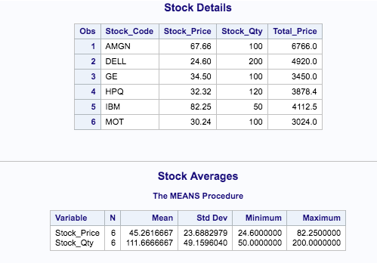

1. Given the program here, add the necessary statements to compute four new variables:
   1. Weight in kilograms (1 kg=2.2 pounds). Name this variable WtKg.
   2. Height in centimeters (1 inch = 2.54 cm). Name this variable HtCm.
   3. Average blood pressure (call it AveBP) equal to the diastolic blood pressure plus one-third the difference of the systolic blood pressure minus the diastolic blood pressure.
   4. A variable (call it HtPolynomial) equal to 2 times the height squared plus 1.5 times the height cubed.

Here is the program for you to modify:

**data** prob2;

input ID $

Height /*in inches*/

Weight /*in pounds*/

SBP /*systolic BP*/

DBP /*diastolic BP*/;

< place your statements here >

datalines;

001 68 150 110 70

002 73 240 150 90

003 62 101 120 80

;

title “Listing of PROB2”;

**proc** **print** data=prob2;

**run**;

Code:

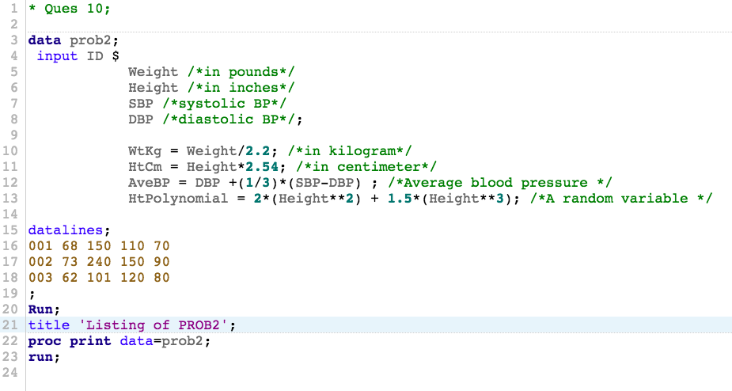

Log:

|  |
| --- |
| 1 OPTIONS NONOTES NOSTIMER NOSOURCE NOSYNTAXCHECK;  72  73 * Ques 10;  74  75 data prob2;  76 input ID $  77 Weight /*in pounds*/  78 Height /*in inches*/  79 SBP /*systolic BP*/  80 DBP /*diastolic BP*/;  81  82 WtKg = Weight/2.2; /*in kilogram*/  83 HtCm = Height*2.54; /*in centimeter*/  84 AveBP = DBP +(1/3)*(SBP-DBP) ; /*Average blood pressure */  85 HtPolynomial = 2*(Height**2) + 1.5*(Height**3); /*A random variable */  86  87 datalines;    NOTE: The data set WORK.PROB2 has 3 observations and 9 variables.  NOTE: DATA statement used (Total process time):  real time 0.01 seconds  cpu time 0.01 seconds    91 ;    92 Run;  93 title 'Listing of PROB2';  94 proc print data=prob2;  95 run;    NOTE: There were 3 observations read from the data set WORK.PROB2.  NOTE: PROCEDURE PRINT used (Total process time):  real time 0.06 seconds  cpu time 0.06 seconds      96  97  98 OPTIONS NONOTES NOSTIMER NOSOURCE NOSYNTAXCHECK;  111 |

Results:

